Name:Dheeraj
Regno:23MIS0474

AGILE DEVELOPMENT AND DEVOPS LAB

Case Study-1

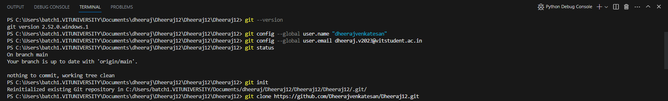
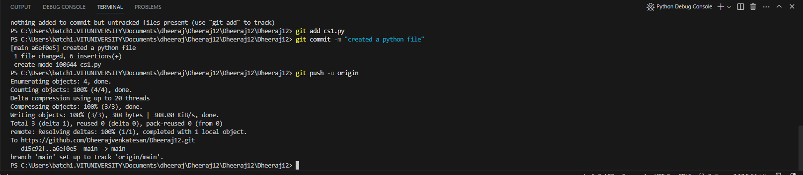
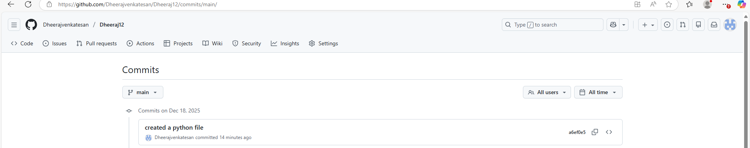
Case Study-2

